Kiosk Will Not Power On

Issue
If the EVOLT kiosk does not power on, follow these steps to verify the power connection and identify potential hardware issues.

🔌 Step 1: Check Power Connection
- Verify Power Cord Placement
  - Ensure the power cord is fully seated into the power pack.
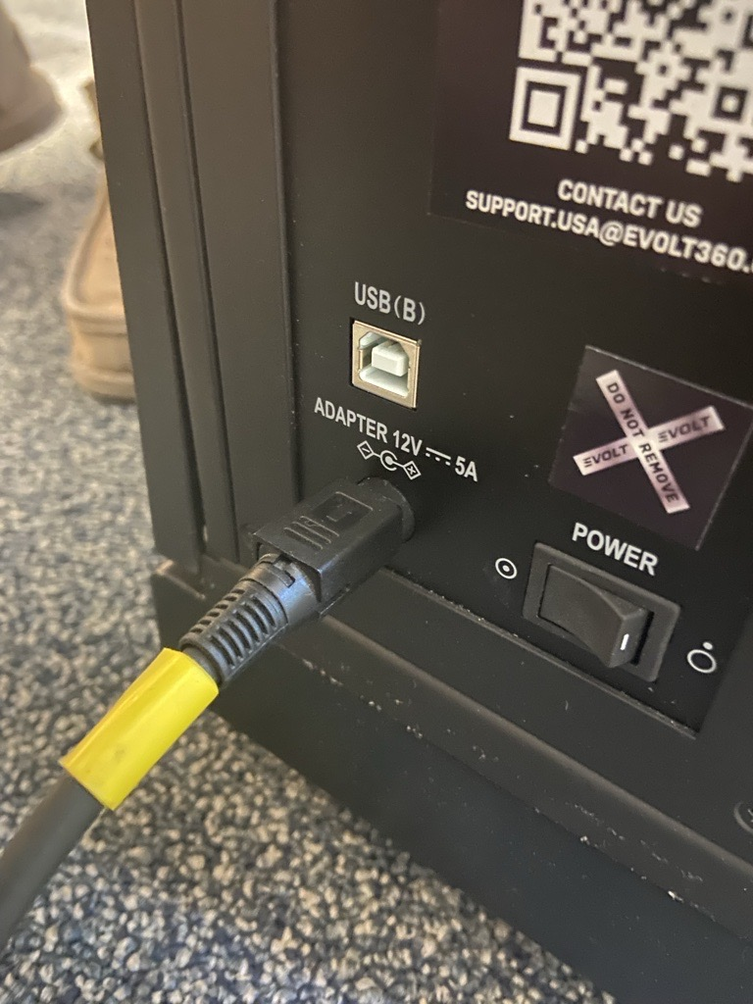
  - Confirm it is plugged into a working outlet or surge protector (use of a surge protector is strongly recommended).

- Check Power Cord Orientation
  - Inspect the connection at the back of the unit:
    - The flat side of the power cord port must be facing upward.
- Confirm Power Switch Position
  - The “ON” position is indicated by the circle with a dot inside (⭘•).

💡 Step 2: Check for Internal Power Indicators
- Inspect Vent Lights
  - Look for any lights visible through the vents located under the screen.
- Interpret Light Status
  - Lights visible: Power is reaching the unit, but there may be a fault with the Power Board or Motherboard.
    - Escalate to the EVOLT Support Team to coordinate a hardware repair.
  - No lights visible: Most likely a failure in the power cord or power pack.
    - Escalate to the EVOLT Support Team to arrange a replacement power pack.

